|  |  |
| --- | --- |
| Figure - Alan Turing aged 16(1928)  Playing the Turing Game (NAG-21-266)  Software Design Description | Abstract  This document outlines the Design for the Turing game solution, it will cover considerations with regards to targeted operating systems and any software or hardware concerns.  Callum Gray  Playing the Turing Game (NAG-21-266)  Issue: 1 Draft A  Word Count: 1218  14 February 2022 |

# Amendment History

| Issue | Date | Details of Amendments | Amended By |
| --- | --- | --- | --- |
| 1 draft A | Dec 21 | Created first draft of requirements document | Callum Gray |
|  |  |  |  |
|  |  |  |  |
|  |  |  |  |
|  |  |  |  |
|  |  |  |  |
|  |  |  |  |
|  |  |  |  |

# Distribution

|  |  |
| --- | --- |
| Name | Role |
| Callum Gray | Project Lead |
| Bing Wang | Project supervisor |
| Neil Gordon | Project Second Marker |
|  |  |
|  |  |
|  |  |
|  |  |

# Table of Contents

Amendment History 1

Distribution 1

Table of Contents 2

Abbreviations 4

1. Scope 5

1.1. Identification 5

1.2. System Overview 5

1.3. Document Overview 5

2. Referenced Documents 6

3. CSCI-wide Design Decisions 7

3.1. Interfaces and expected Inputs/Outputs 7

3.2. Safety security and Privacy considerations 7

3.2.1. Safety considerations 7

3.2.2. Security considerations 7

3.2.3. Privacy considerations 7

4. CSCI Architectural design 8

4.1. CSCI Components 8

4.1.1. The Client Application 8

4.1.2. The controller application 8

4.1.3. The Chatbot 9

4.2. Concept of execution 9

4.2.1. Concept of execution outline 9

4.2.2. Timing diagrams 9

4.3. Interface design 9

4.4. Interface Identification and diagrams 9

5. CSCI Detailed design 10

5.1. Client application Design 10

5.1.1. Client Application UML diagram 10

5.1.2. Client Application Classes and functions 10

5.2. Controller Application Design 10

5.2.1. Controller Application UML diagram 10

5.2.2. Controller Application Classes and functions 10

5.3. Chatbot Design 10

5.3.1. Chatbot wrapper UML diagram 10

5.3.2. Chatbot Wrapper Classes and functions 10

6. Requirement Traceability 11

7. UI Design Concepts 12

Table of Figures 13

References 13

# Abbreviations

|  |  |
| --- | --- |
| **Abbreviation** | **Word or Phrase** |
| CSCI | Computer Software Configuration Item |
| TGF | Turing Game Framework |
| SRS | Software Requirement Specification |
| CA | Client Application |
| SA | Server Application |
| UI | User Interface |
|  |  |

# Scope

## Identification

The Table below identifies the Turing Game System

The Contents of this document should be used as for the design and creation of a System/Framework that will aid a teacher in a classroom to explain the principle behind the Turing Game. This document contains key aspects that cover the design, requirements, and Testing of the Turing Game Framework the students will be allocated a room with either another student or an AI. They Will also be given a role either interviewer or subject

## System Overview

An overview of the Turing Game Framework is a Framework that will allow one or more users to take part in the Turing Game, a thought experiment devised by Alan Turing to test whether a computer was Truly intelligent. The aim of this framework is for it to be designed with education in mind being able to use the framework in a school setting to demonstrate the Concept to younger students. It will be made up of two parts a Controller/Server Application and the client application. Along with a form of chatbot to take the place of the AI.

## Document Overview

This Document will cover the designs and decisions made for the Turing game framework and its constituent parts. This includes:

* Decisions that affect the outcome/ design of the CSCI
* Interfaces and communication between the various parts of the CSCI
* Privacy and safety concerns for the design
* Data storage and access.

The document should be used to inform the production of the Frame work concerned.

# Referenced Documents

|  |  |  |
| --- | --- | --- |
| Document Title | Document description | Reference |
| MIL-STD-498-SDD-PID | This Document is a template for creating a SDD document to the appropriate standard | MI-STD-SDD |
| 2021-22 SRS Playing the Turing Game | This Document Outlines and details the Requirements that the TGF system must be deigned to accommodate and fulfill | TGF_SRS |
|  |  |  |

# CSCI-wide Design Decisions

## Interfaces and expected Inputs/Outputs

Each Component of the TGF System is going to be a stand-alone application that will communicate using network sockets to interface with each other. The Three Components Will All receive String as outputs from the interfaces and send Strings inputs to the interfaces.

The chat bot Application will have an additional interface in the form of a Wrapper class that will allow the Chatbot to connect to the network sockets and transfer the received data to the chatbot

The Applications which have user facing elements will be designed using MVVM concepts to make the framework more flexible and adaptable in future. This decision has been made to allow Different front ends to be applied to it which are more suited to the audience for example if aimed to be used with primary school age students then it may require a more child friendly UI, or if is to be used with secondary school age students then a User interfaced that appears lees childish may be appropriate. By conforming to MVVM methodology the Front end can be swapped ou without affecting the actual operation of the TGF system.

## Safety security and Privacy considerations

### Safety considerations

### Security considerations

The TGF will be broad casting the data across a local network meaning the only visibility for the data should be local and should not contain any data that is of a secret or high security nature regardless encryption of the messages could be considered.

### Privacy considerations

The TGF system will not collect any data from the users therefore no data storage privacy concerns need to be considered such as GDPR. As each Client is kept anonymous throughout and the only information revealed about them to others is whether they are a robot or a human.

# CSCI Architectural design

## CSCI Components

|  |  |
| --- | --- |
| Software Item Component | Project Unique Identifier |
| The Client Application | TGF_CA |
| The Controller Application | TGF_SA |
| The Chatbot | TGF_CB |

The CSCI will be made up of 3 main components these are:

### The Client Application

The Client application is the application that the students would interact with it will be able to handle sending and receiving data such as messages it will have three states/modes.

the first will be the initial state, in this state the application will display a screen to the student akin to a log in screen asking for a session number.

The second mode is the Interviewer mode in this mode the user will be shown a screen which will display the message history for the current session, it will have a text entry method, a button to send the entered text and a button to vote on their determination. It will also inform them that they are the Interviewer

The third mode is the Subject Mode this mode will be very similar to the Interviewer Mode however there will not be the option to choose their determination. And the screen will inform the user that they are the Subject.

### The controller application

The controller application is the Application that the teacher/ demonstrator will interact with it will handle the connecting of the Client applications and handle the interactions with the chat bot, it will have two states/modes

The first state is the initial state, in this state the Controller will present a screen displaying a session number to be entered into the Client applications

The second mode is the Active mode in this mode the controller will display the various rooms that are currently in use and allow the teacher/ demonstrator to view the messages being shared in these rooms. The Controller will also allocate the Chatbot to one or more rooms which will also be displayed on the screen.

### The Chatbot

The chat bot is never directly interacted with by the users but by the controller via a wrapper class that will interface the two the chatbot itself will only have once state/mode and will take in Strings as an input and send strings as an output.

## Concept of execution

### Concept of execution outline

The Concept of execution for using the TGF system is as follows:

The Teacher/Demonstrator will load up the Controller Application which will provide a session code for the Controller.

The students then load up the Client applications and enter the Session code provided by the teacher this will connect the Clients to the Controller.

The Controller will then allocate each Client a Role and link them to a room where they will be paired up with the opposite role or the Chatbot.

The Interviewer Client will then be able to post questions into the room, which will be relayed via the Controller. If the Interviewer is paired with the Chatbot then it will Send the String of the message to the Chat bot via the wrapper. The Chatbot will then process the string and return its response which will be relayed to the Interviewer via the controller the wrapper will allow the Chatbot to appear the same as another Client app user.

### Sequence diagrams

The below diagram shows the Concept of execution for the TGF.

The below diagram shows the Concept of execution for the Client application.

The below diagram shows the Concept of execution for the Controller application.

The below diagram shows the concept of execution for the Cheat bot.

## Interface design

## Interface Identification and diagrams

# CSCI Detailed design

## Client application Design

### Client Application UML diagram

### Client Application Classes and functions

This section describes each class that makes up the Client application. It also describes each function that belongs to the class and their intended inputs/outputs as well as their purpose.

## Controller Application Design

### Controller Application UML diagram

### Controller Application Classes and functions

This section describes each class that makes up the Controller application. It also describes each function that belongs to the class and their intended inputs/outputs as well as their purpose.

## Chatbot Design

### Chatbot wrapper UML diagram

### Chatbot Wrapper Classes and functions

This section describes each class that makes up the Chat bot as well as the wrapper class that will be used to interface it. It also describes each function that belongs to the class and their intended inputs/outputs as well as their purpose.

# Requirement Traceability

# UI Design Concepts

This section of the document will show mock-ups for what the User Interfaces could look like and design considerations that have gone into them.

## Client application

### Initial State

The below image is a mock-up of the initial screen shown to users of the Client application it allows for the session number to be entered in order to connect to the Controller Application

### Subject Mode

The image below is a mock-up of the layout for the TGF_CA Subject Mode to give some perspective on what the student will see when they use the application.

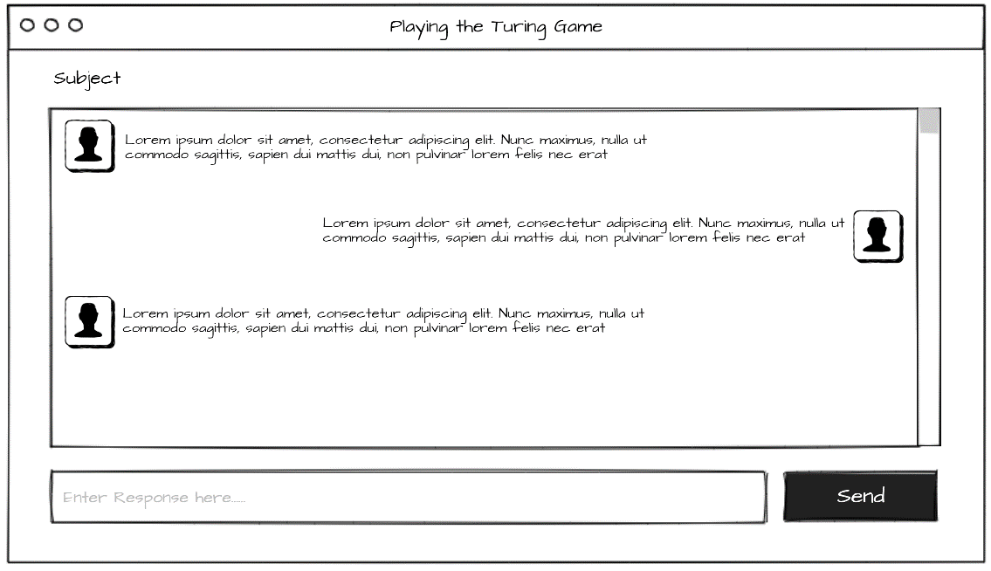

A method of text entry to allow the user to enter the responses to the questions they receive.

A method of displaying the conversation history for the session

A method to allow the user to post the users response

### Interviewer Mode

The image below is a mock-up of the layout for the TGF_CA Interviewer Mode to give some perspective on what the student will see when they use the application.

A method of displaying the conversation history for the session

A method of text entry to allow the user to enter the responses to the questions they receive.

A method to allow the user to post the users response

A method to allow the user to select what they think they are talking to

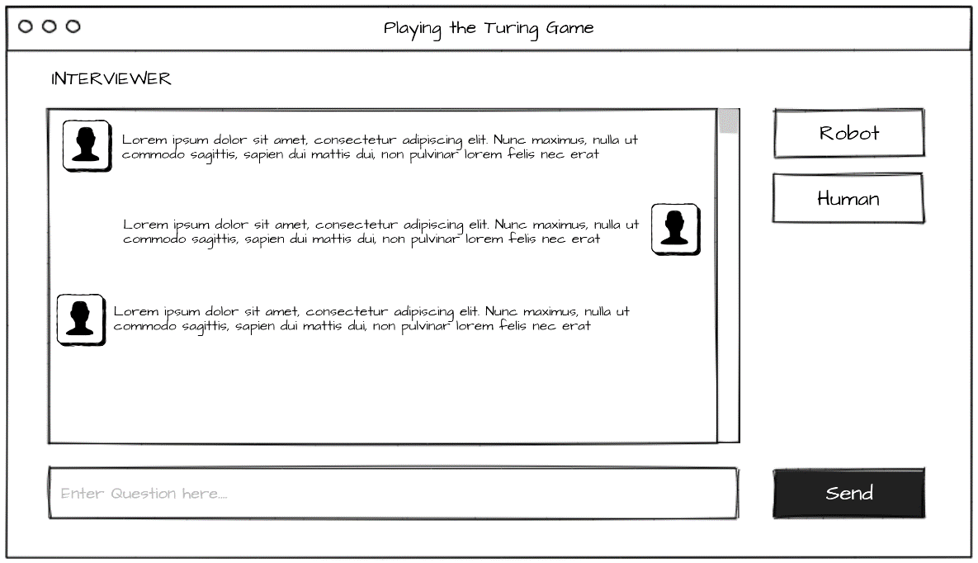

## Controller application

The image below is a Mock up of the UI layout for the Controller application

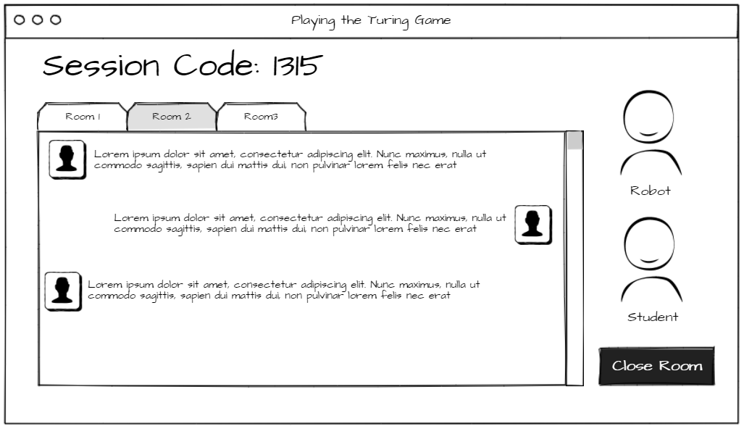

A method to display the session code used to connect the Clients to the Controller.

A method t display who is in each room e.g. Robot or human

A method to allow the user to view the different rooms and the conversations happening in each one

A method to allow the controller to close a room and disconnect the Clients

# Table of Figures

[Figure 1 - Alan Turing aged 16(1928) 0](https://d.docs.live.net/00ae35dcf5f19903/Documents/UniWork/DISERTATION/2021%20-22%20SDD%20Playing%20the%20Turing%20Game%20(NAG-21-266).docx#_Toc95052757)

# References

Anon., n.d. *software Safety.* [Online]   
Available at: https://www.systemsafetyengineering.com/software-safety.html  
[Accessed 23 December 2021].

Copeland, B. J., 2005. The Essential Turing: The ideas that gave birth to the computer age. *Oxford: Oxford University Press.*

Turing, A., 1950. *Computing Machinery and Intelligence.* Manchester: s.n.